Information and Questionnaire for Senior Consultant Ecologist Candidates
Your application will be assessed against a CAPABLE CIEEM level of competence, in line with Senior Consultant Ecologist. The examples you provide in this questionnaire and at interview should meet the criteria associated with a CAPABLE CIEEM level of competence.
When completed please return this document with your CV to jobs@scottcawley.com
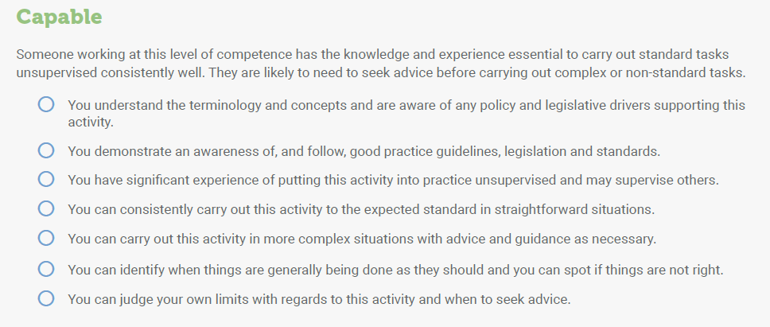
Where did you see this role advertised (please select all that apply):
Scott Cawley Website ☐
Scott Cawley LinkedIn Page ☐
www.ecocareers.ie ☐
Word of mouth ☐
Recruitment agency ☐
College Careers Board ☐ Please specify college____________
Jobs Board ☐ Please specify______________
Other ☐ Please specify______________

Experience listing
Please tick the number of surveys/projects that you have undertaken.
 | Not undertaken | Less than 5 projects | 5 -10 | 10 -50 | More than 50
Field Skills
Habitat Survey (to either Extended Phase 1 or Fossitt 2000 standard)
Annex 1 Habitats
Vegetation community classification (UK NVC or similar) including taking relevé samples
Bat Surveys
Badger surveys
Otter surveys
Reptile surveys
Amphibian surveys
Marsh Fritillary Surveys
Freshwater invertebrate sampling
Winter bird surveys
Breeding bird surveys
Invasive plant species surveys
Other surveys not covered above – please specify
Mapping Skills
GIS experience (e.g. QGIS or ArcGIS - please specify)

Reporting Experience - Please insert the approx. number of projects you have been involved in for each report type under the relevant heading.

 | Baseline Write-Up Only | Contributor to Impact Assessment | Lead Author | Reviewer/Sign-off
Baseline Survey Reports

AA Screening

Ecological Impact Assessment/
Biodiversity Chapter
Natura Impact Statement

Derogation Licence Applications

Report
Please outline one example of a report you have written detailing:
- Whether you were lead/sole/contributing author
- What the purpose of the report was
- Summary of field work undertaken to inform the report
- Key conclusions/findings of the report

If possible, please supply a copy of the referenced report.

Maximum 500 words

Availability for commencing employment and/or notice period

Career goals – within 1 year
Career goals – within 5 years
Salary expectations

Do you own a vehicle and full EU driving licence?
List two Referees who may be contacted should you be offered a position.

Annex A - Scott Cawley Vision, Mission and Values
